Connecting to ParentMail

Please follow the following steps to activate your account:

- On your emails you should receive an email from ParentMail; please click the link to register.
- Next the image below should appear on your screen. Please choose the following options:
- I already have a ParentMail account.
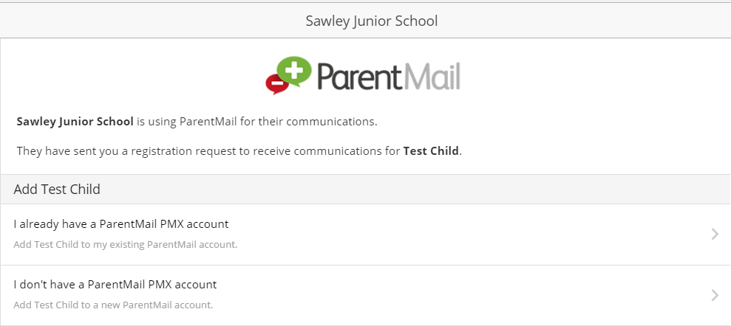
- I don’t have a ParentMail account.
………….
………..

- After choosing which option you need, please enter your child’s date of birth.
- Next please verify your details and create a password.
- Finally click register.

Your account should now be registered and you should be able to access all the payment options and make any contact updates.

If you have any problems, please don’t hesitate to ask the school office.

